**Assignment 01**

**Zirwah Khalil Computer Networks**

**i220748 BSCS-C**

**Q1**

(1)

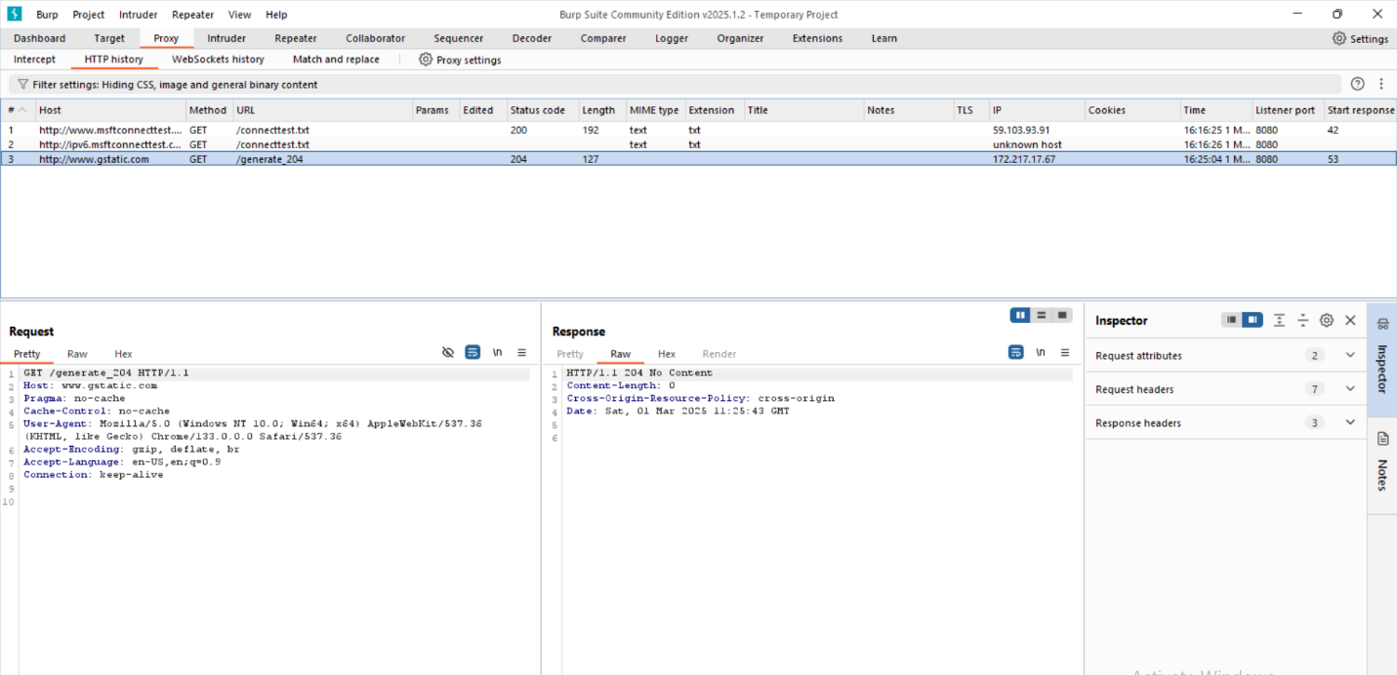

Request Headers:

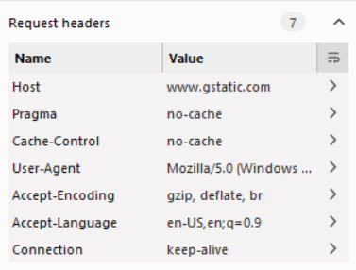  
Response Headers:

Security vulnerabilities: Missing HTTPS

(2)

Output:

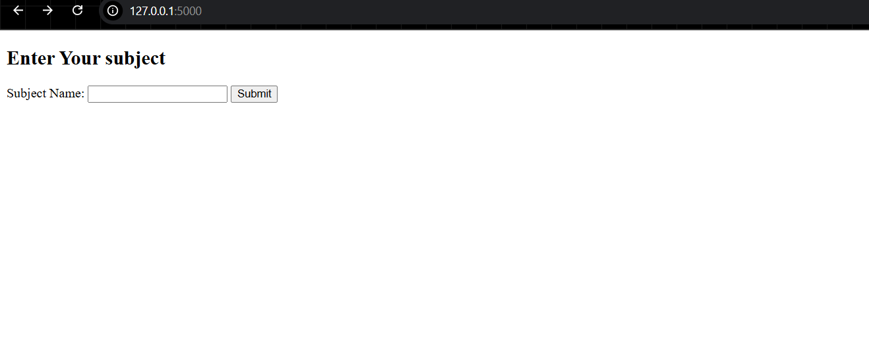

Enter the subject name in the box, then **SUBMIT**.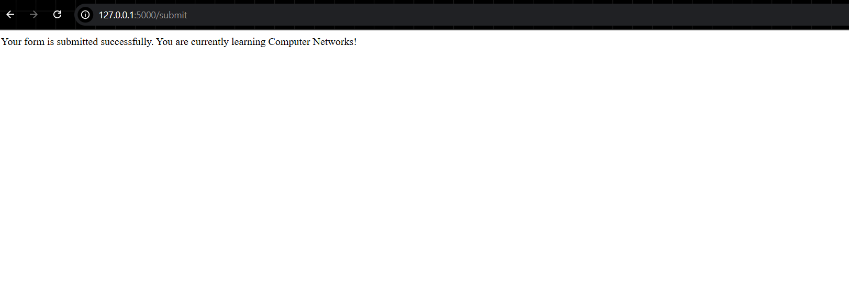

**Q2**

(1)

**nslookup** command run for “facebook.com”

type A

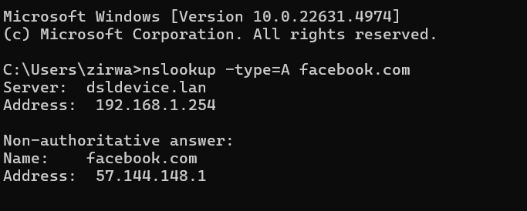

Type AAAA

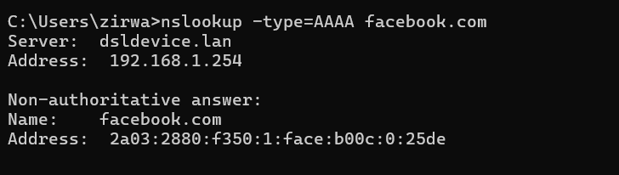

Type MX

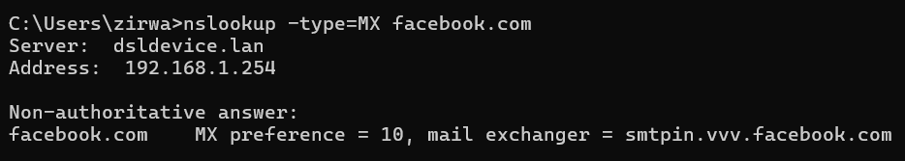

Type NS

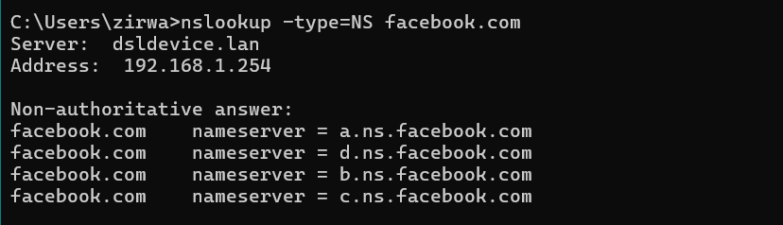

IP address of university Website  
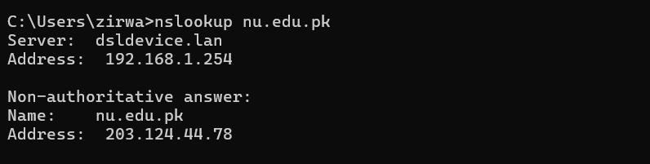

**Q3**

Email sent to Mailtrap inbox.

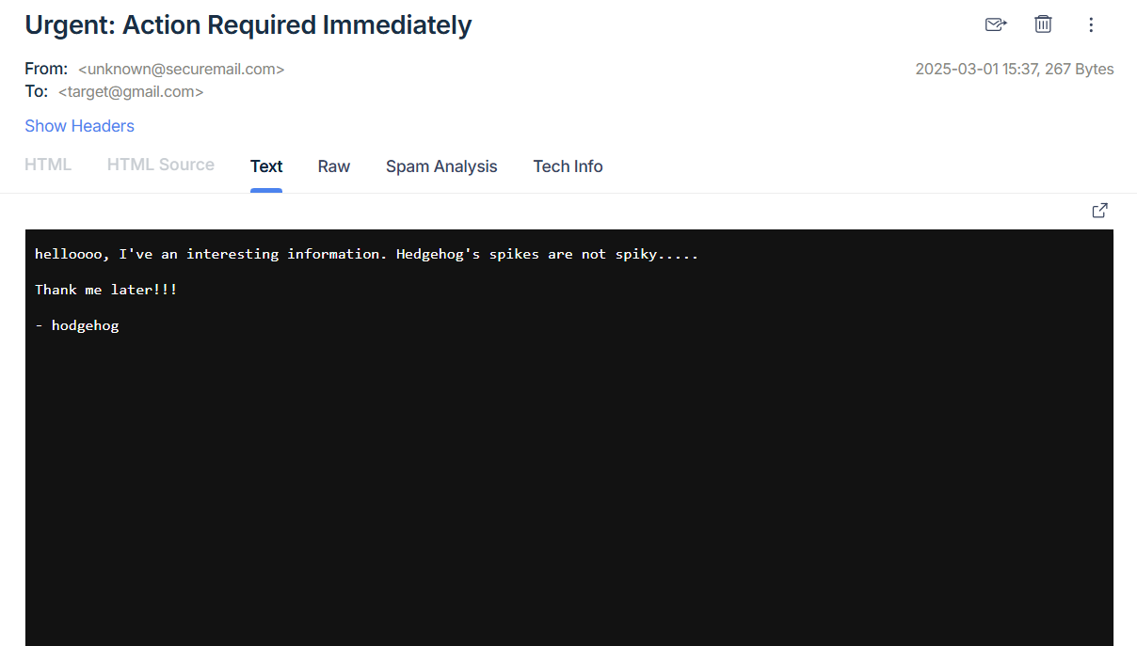

**Q5**

(1)  
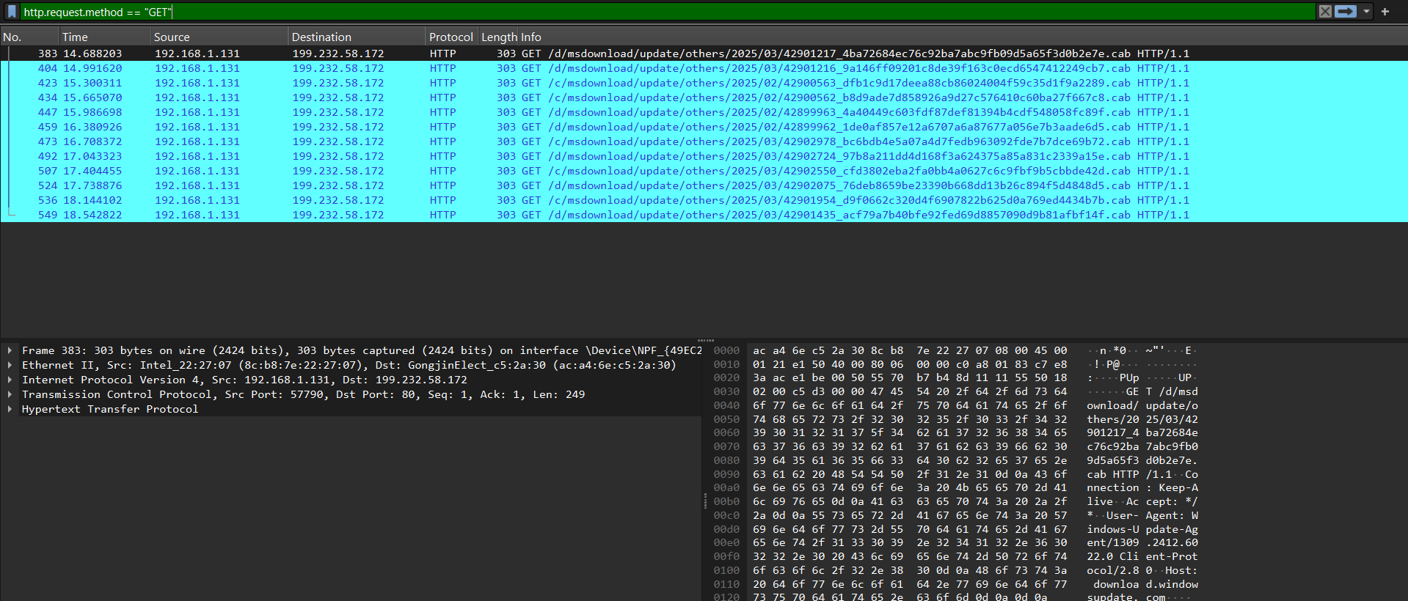

Command used to filter HTTP packets: **http.request.method == "GET"**

DNS

Command used to filter HTTP packets: **dns && dns.flags.response == 1**

FTP

Capturing FTP

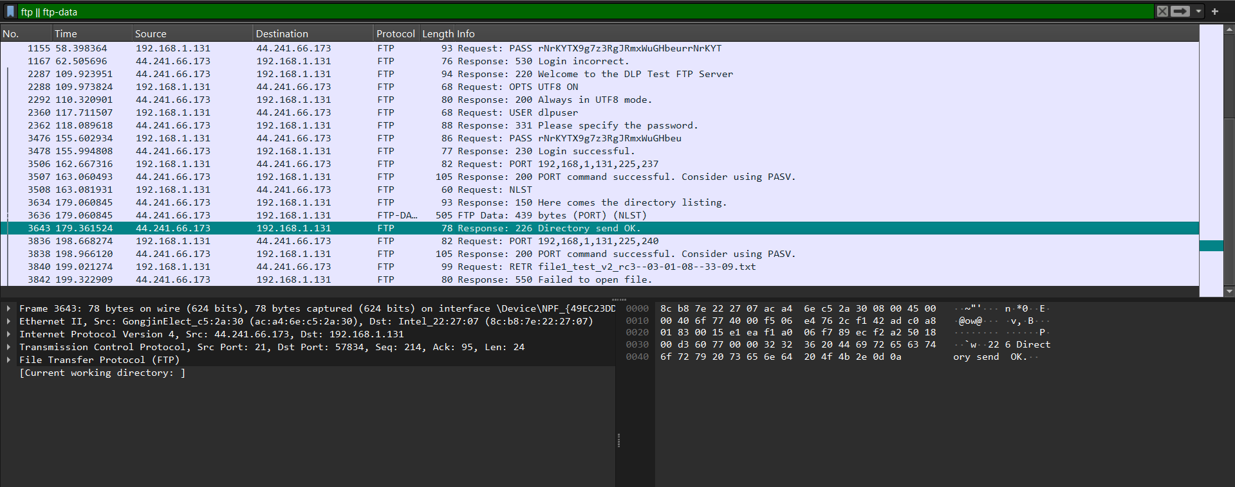

(2) -a

Requested URL: <http://download.windowsupdate.com/d/msdownload/update/others/2025/03/42901217_4ba72684ec76c92ba7abc9fb09d5a65f3d0b2e7e.cab>

User Agent: Windows-Update-Agent  
Cookies: No cookies

(2) -b

Explanation for “How HTTPS protects sensitive data as compared to HTTP”

🔹 **HTTP is insecure** because data is sent in **plain text**, allowing attackers to intercept login credentials, cookies, and sensitive data.  
🔹 **HTTPS encrypts data using TLS (Transport Layer Security)**, preventing attackers from reading network traffic.

**Q6**

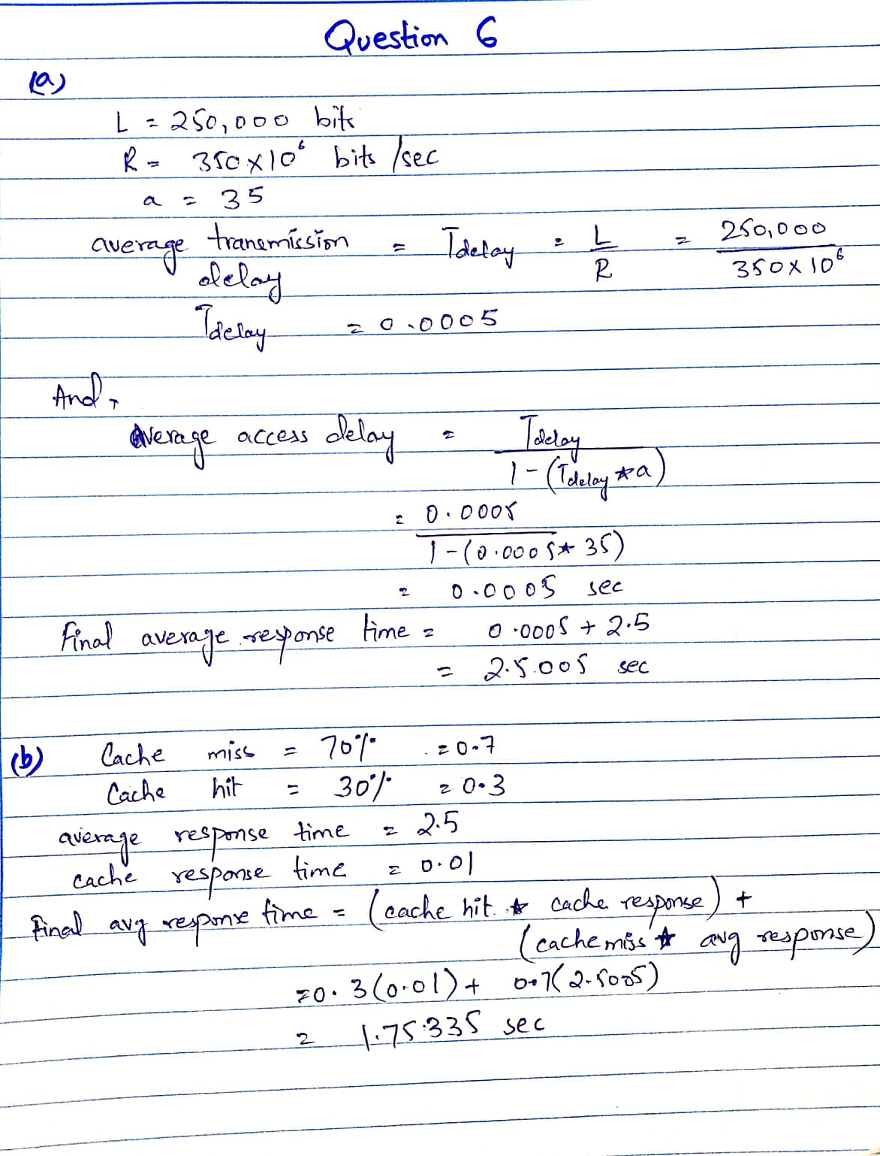

Thus, the average response time has **reduced** from **2.5005** to **1.75335 seconds**.

**Q7**

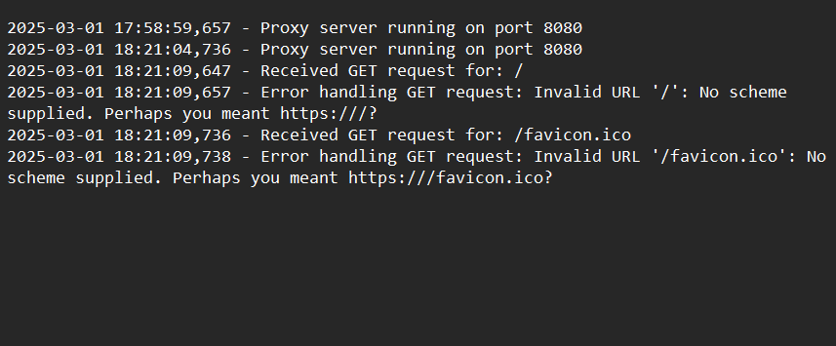

proxy.log file after running python code and searching <http://localhost:8080> on browser.